

POLITICS AND LAW SAMPLE EXAMINATION

STAGE 3

Section 7 of the New WACE Manual: General Information 2006–2009 outlines the policy on WACE examinations.

Further information about the WACE Examinations policy can be accessed from the Curriculum Council website at http://newwace.curriculum.wa.edu.au/pages/about_wace_manual.asp.

The purpose for providing a sample examination is to provide teachers with an example of how the course will be examined. Further finetuning will be made to this sample in 2008 by the examination panel following consultation with teachers, measurement specialists and advice from the Assessment, Review and Moderation (ARM) panel.

0000.doc




Western Australian Certificate of Education, Sample External Examination
Question/Answer Booklet

POLITICS AND LAW
Please place your student identification label in this box
WRITTEN PAPER
STAGE 3

Student Number: In figures

In words

Time allowed for this paper
Reading time before commencing work: Ten minutes
Working time for paper: Three hours

Material required/recommended for this paper

To be provided by the supervisor
This Question/Answer Booklet

To be provided by the candidate
Standard items: Pens, pencils, eraser or correction fluid, ruler, highlighter

Important note to candidates
No other items may be taken into the examination room. It is your responsibility to ensure that you do not have any unauthorised notes or other items of a non-personal nature in the examination room. If you have any unauthorised material with you, hand it to the supervisor before reading any further.

Structure of this paper

Section | Suggested working time | Number of questions available | Number of questions to be attempted | Marks
One:  Short answers | 45 minutes | 5 | 3 | 30 (30%)
Two:  Source analysis | 35 minutes | 2 | 1 | 20 (20%)
Three:  Essays | 100 minutes | 5 | 2 | 50 (50%)
 |  |  | [Total marks] | 100

Instructions to candidates
- The rules for the conduct of Curriculum Council examinations are detailed in the Student Information Handbook. Sitting this examination implies that you agree to abide by these rules.

SECTION ONE: SHORT ANSWERS

In this section there are FIVE (5) questions. Answer THREE (3) questions only. Each question is worth 10 marks.

Allow approximately 45 minutes for this section [30 marks].

Question 1
(a) Explain the term ‘human rights’. [2 marks]

____________________________________________________________________________________________________________________________________________________________________________________________________________________________________________________________________________________________________________

(b) Outline three ways rights are currently protected in Australia. [3 marks]

__________________________________________________________________________________________________________________________________________________________________________________________________________________________________________________________________________________________________________________________________________________________________________________________________________________________________________________________________

(c) With reference to one explicit right in the Australian Constitution, evaluate how it protects individuals. [5 marks]

________________________________________________________________________________________________________________________________________________________________________________________________________________________________________________________________________________________________________________________________________________________________________________________________________________________________________________________________________________________________________________________________________________________________________________________________________________________

Question 2
(a) Explain the term ‘equity’ in the context of the Australian political and legal system.
[2 marks]

____________________________________________________________________________________________________________________________________________________________________________________________________________________________________________________________________________________________________________

(b) Outline three ways that international legal covenants can enhance human rights in Australia. [3 marks]

__________________________________________________________________________________________________________________________________________________________________________________________________________________________________________________________________________________________________________________________________________________________________________________________________________________________________________________________________

(c) Present an argument for and against a country being bound by an international legal covenant. [5 marks]

________________________________________________________________________________________________________________________________________________________________________________________________________________________________________________________________________________________________________________________________________________________________________________________________________________________________________________________________________________________________________________________________________________________________________________________________________________________

Question 3
(a) Explain the term ‘consensus’ in relation to governance. [2 marks]

____________________________________________________________________________________________________________________________________________________________________________________________________________________________________________________________________________________________________________

(b) Outline three political or legal processes that exist to promote a democratic state.
[3 marks]

__________________________________________________________________________________________________________________________________________________________________________________________________________________________________________________________________________________________________________________________________________________________________________________________________________________________________________________________________

(c) Evaluate one source of and one limitation of prime ministerial power. [5 marks]

________________________________________________________________________________________________________________________________________________________________________________________________________________________________________________________________________________________________________________________________________________________________________________________________________________________________________________________________________________________________________________________________________________________________________________________________________________________

Question 4
(a) Distinguish between ministry and cabinet in the Australian political system.
[2 marks]

____________________________________________________________________________________________________________________________________________________________________________________________________________________________________________________________________________________________________________

(b) Outline three principles of responsible government. [3 marks]

__________________________________________________________________________________________________________________________________________________________________________________________________________________________________________________________________________________________________________________________________________________________________________________________________________________________________________________________________

(c) Evaluate one way that parliaments have to keep an executive accountable. [5 marks]

________________________________________________________________________________________________________________________________________________________________________________________________________________________________________________________________________________________________________________________________________________________________________________________________________________________________________________________________________________________________________________________________________________________________________________________________________________________

Question 5
(a) Define 'the media’. [2 marks]

____________________________________________________________________________________________________________________________________________________________________________________________________________________________________________________________________________________________________________

(b) Outline three ways the media have to influence the Australian political and legal system. [3 marks]

__________________________________________________________________________________________________________________________________________________________________________________________________________________________________________________________________________________________________________________________________________________________________________________________________________________________________________________________________

(c) 'The media has too much power within the Australian political and legal system.' Present one argument to support this statement and one argument against it. [5 marks]

________________________________________________________________________________________________________________________________________________________________________________________________________________________________________________________________________________________________________________________________________________________________________________________________________________________________________________________________________________________________________________________________________________________________________________________________________________________

END OF SECTION ONE

SECTION TWO: SOURCE ANALYSIS

In this section there are TWO (2) document sets. Choose Document Set One or Document Set Two. Answer the question relating to the document set you have chosen. The question is worth 20 marks.

Allow approximately 35 minutes for this section [20 marks].

Read the document below and answer the question that follows.

Document Set One
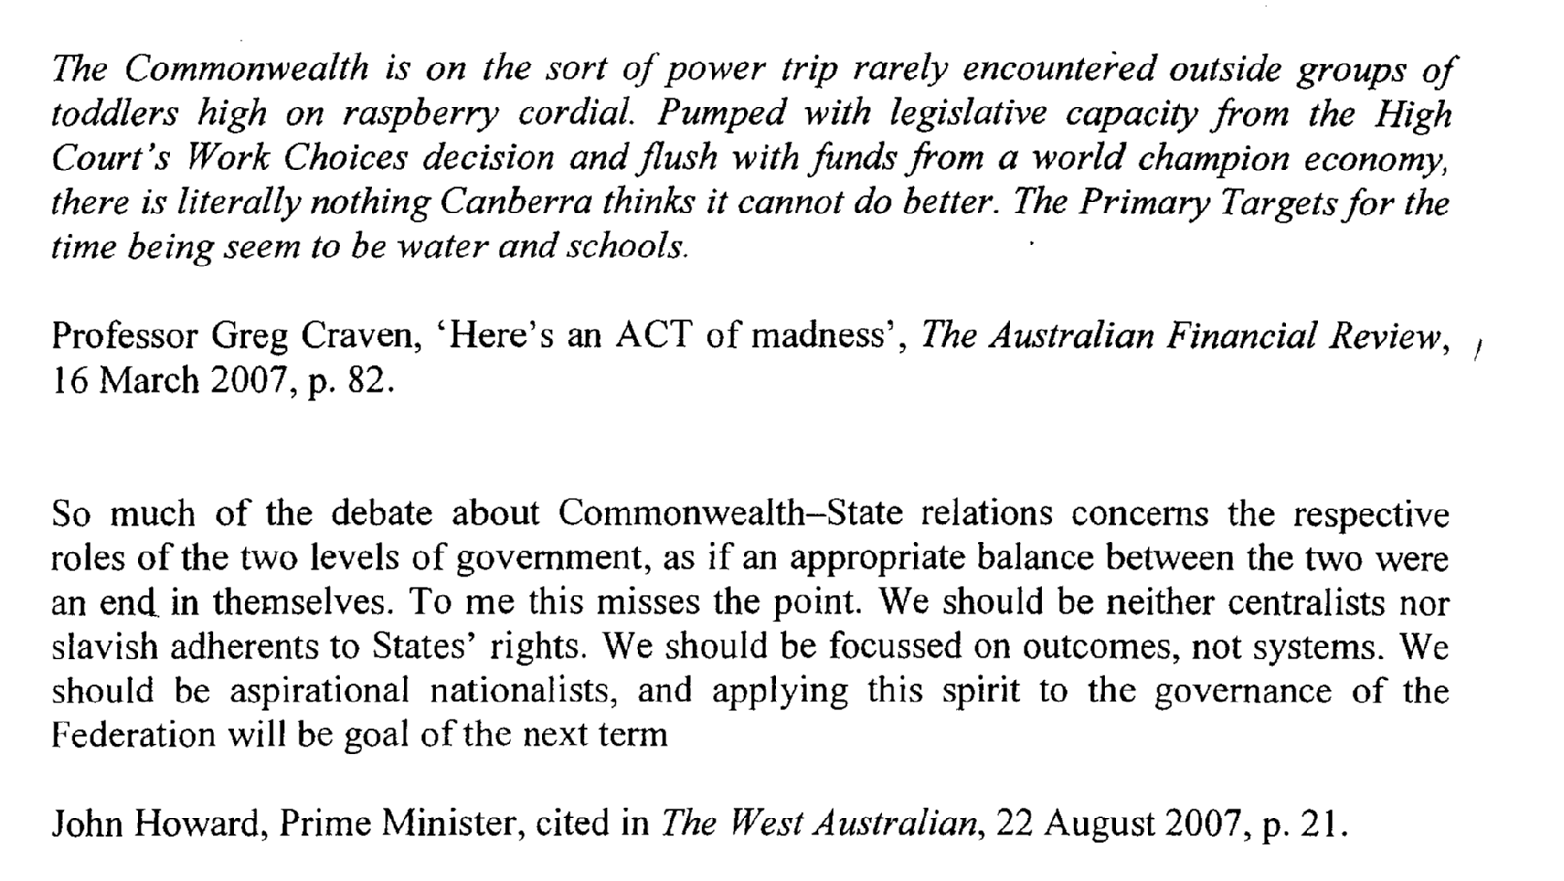

For copyright reasons this text cannot be reproduced in the online version of this document.

For copyright reasons this text cannot be reproduced in the online version of this document.

With reference to Document Set One and your studies of Politics and Law, answer the following questions.

Question 6
(a) What is a 'federal system'? [2 marks]

____________________________________________________________________________________________________________________________________________________________________________________________________________________________________________________________________________________________________________
(b) With reference to the source, explain why Professor Greg Craven has referred to 'work choices', 'water' and 'schools' in his article. [4 marks]

________________________________________________________________________________________________________________________________________________________________________________________________________________________________________________________________________________________________________________________________________________________________________________________________________________________________________________________________________________________________________________________________________________________________________________________________________________________
(c) With reference to the source, compare and contrast the federalist views of Prime Minister John Howard and Professor Greg Craven. [6 marks]

____________________________________________________________________________________________________________________________________________________________________________________________________________________________________________________________________________________________________________________________________________________________________________________________________________________________________________________________________________________________________________________________________________________________________________________________________________________________________________________________________________________________________________________________________________________________________________________________________________________________________________________________________________________________________________________________________
(d) With reference to the source and your study of Politics and Law, discuss which perspective of federalism is likely to have the greater support within Australia today.
[8 marks]

________________________________________________________________________________________________________________________________________________________________________________________________________________________________________________________________________________________________________________________________________________________________________________________________________________________________________________________________________________________________________________________________________________________________________________________________________________________________________________________________________________________________________________________________________________________________________________________________________________________________________________________________________________________________________________________________________________________________________________________________________________________________________________________________________________________________________________________________________________________________________________________________________________________________________________

Document Set Two

Source One
Bill of Rights Poll (for the Commonwealth) (24 July and 30 July 200—Roy Morgan Research)
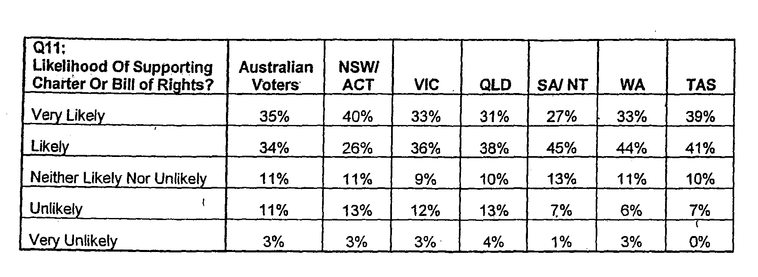

For copyright reasons this information cannot be reproduced in the online version of this document but may be viewed at
http://acthra.anu.edu.au/articles/Anti-terror%20community%20survey%20report.pdf
(Q.11—p.20, Table 2.1—p.2)

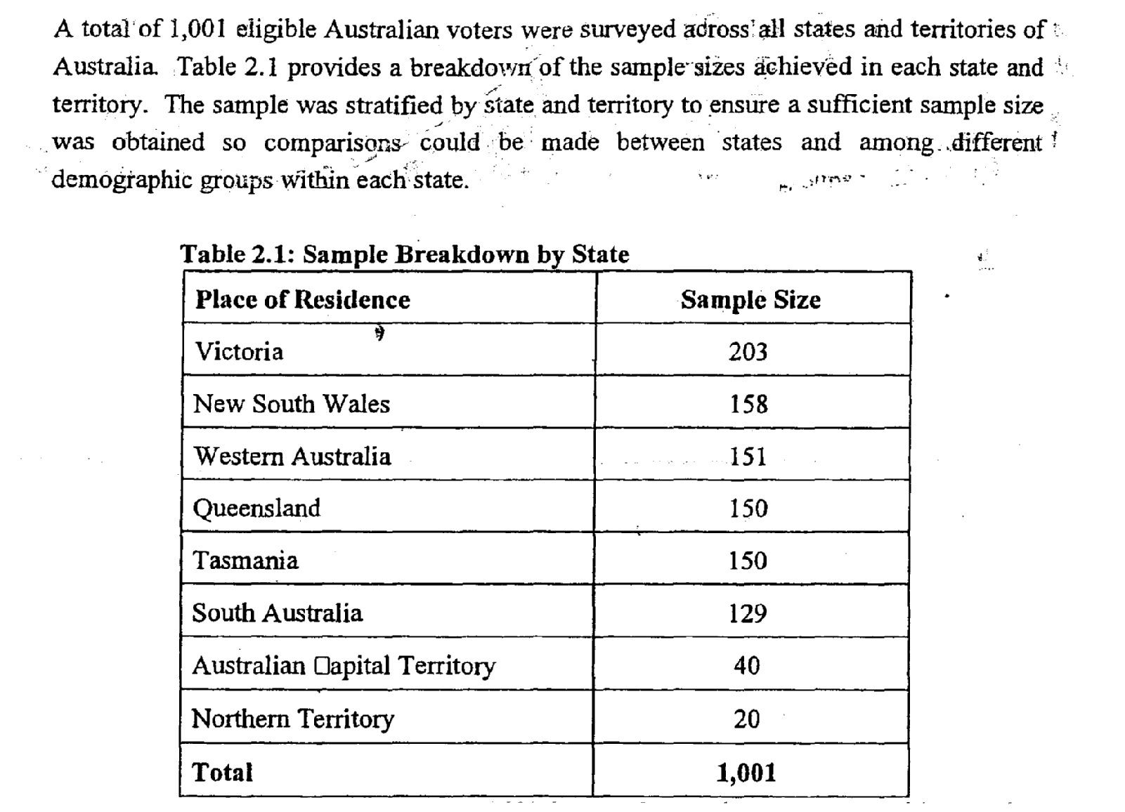

With reference to Document Set Two and your studies of Politics and Law answer the following question.

Question 7
(a) What is a 'bill of rights?' [2 marks]

____________________________________________________________________________________________________________________________________________________________________________________________________________________________________________________________________________________________________________
(b) With reference to Source One, Identify and briefly comment on the trends in poll results and the data in sample breakdown. [4 marks]

_____________________________________________________________________________________________________________________________________________________________________________________________________________________________________________________________________________________________________________________________________________________________________________________________________________________________________________________________________________________________________________________________________________
(c) Explain how a charter or a bill of rights could be included in the Australian constitution and what issues are raised by the poll results in Source One. [6 marks]

______________________________________________________________________________________________________________________________________________________________________________________________________________________________________________________________________________________________________________________________________________________________________________________________________________________________________________________________________________________________________________________________________________________________________________________________________________________________________________________________________________________________________________________________________________________________________________
(d) With reference to the poll results and your studies of Politics and Law, account for the 'very likely' or 'likely' levels of support for a bill of rights in Australia today.
[8 marks]

__________________________________________________________________________________________________________________________________________________________________________________________________________________________________________________________________________________________________________________________________________________________________________________________________________________________________________________________________________________________________________________________________________________________________________________________________________________________________________________________________________________________________________________________________________________________________________________________________________________________________________________________________________________________________________________________________________________________________________________________________________________________________________________________________________________________

END OF SECTION TWO
SECTION THREE: ESSAY

In this section there are FIVE (5) questions. Answer TWO (2) questions only.

Allow approximately 60 minutes for this section [50 marks].

Question 8
Analyse the practices of citizenship in a modern country you have studied.
[25 marks]
OR
Question 9
Significant internal and external factors can lead to a reassessment of aspects of the Australian political and legal system. With reference to at least one such factor, assess its influence on the Australian political and legal system.

[25 marks]
OR
Question 10
'Countries can both undermine or promote democratic principles.' With reference to at least one country, assess the accuracy of this statement.
[25 marks]
OR
Question 11
'Power within the political and legal system takes many forms and is unduly influenced by individuals and groups.' Assess the validity of this statement.
[25 marks]

OR
Question 12
'Since its creation in 1903 the High Court of Australia has often been the focus of controversy.' Evaluate the reasons for this claim.
[25 marks]

Circle the TWO questions you have chosen to answer: Questions 8 / 9 / 10 / 11 / 12

END OF PAPER

ACKNOWLEDGEMENTS

Published by the Curriculum Council of Western Australia
27 Walters Drive
OSBORNE PARK WA 6017

DOCUMENT SET ONE

Source 1: Craven, G. (2007, March 16). Here’s an ACT of madness. Australian Financial Review, p.82.

Rutherford, T. (2007, August 22). Howard’s vision for federalism a poor one. The West Australian, p.21.

DOCUMENT SET TWO

Source 1: Roy Morgan Research. (2006). Anti-terrorism legislation community survey (pp. 17, 2). Retrieved September, 2007, from http://acthra.anu.edu.au/articles/Anti-terror%20community%20survey%20report.pdf.

